

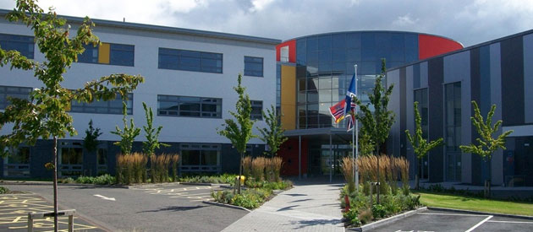

Pupil Handbook

2025/26



****Contents Page**

**Page 3** Belmont Way

**Page 4** Communication

**Page 5** Our School Day

**Page 5** School Uniform

**Page 6** School Lunches

**Page 7** School Curriculum

**Page 8** School Expectations

**Page 9** Mobile Phone Policy

**Page 10** Energy Drink Policy

**Page 11** Toilet Policy

**Page 12** School Map



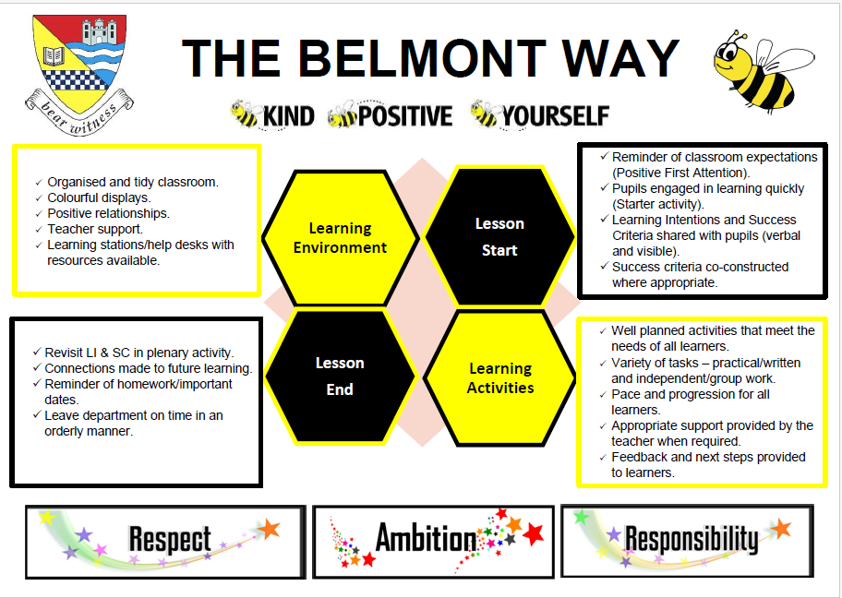

****Communication**

Parentsportal: ​

​

First point of contact – please call main office and ask to speak to Principal Teacher of Guidance or make an appointment for a parental meeting.​

​

Absence – please call when you know your child is not going to attend school. Call the main office number 01292 612 054​.

​

GroupCall Messenger​.

​

School Website: **www.belmont.sayr.sch.uk​**

​

Follows us:  Instagram **Instagram and**  **FacebookFacebook via-**

<https://linktr.ee/belmontacademy>



**Our School Day**

|  |  |  |  |  |  |  |  |  |  |  |
| --- | --- | --- | --- | --- | --- | --- | --- | --- | --- | --- |
|  | **Personal Support** | **P1** | **P2** | **Interval** | **P3** | **P4** | **P5** | **Lunch** | **P6** | **P7** |
| **Mon**  **& Tue** | 8:45 - 8:55 | 8:55 – 9:45 | 9:45 – 10:35 | 10:35 – 10:50 | 10:50 – 11:40 | 11:40 – 12:30 | 12:30 – 1:20 | 1:20 – 2:00 | 2:00 – 2:50 | 2:50 – 3:40 |

|  |  |  |  |  |  |  |  |  |  |
| --- | --- | --- | --- | --- | --- | --- | --- | --- | --- |
|  | **Personal Support** | **P1** | **P2** | **Interval** | **P3** | **P4** | **Lunch** | **P5** | **P6** |
| **Wed, Thu & Fri** | 8:45 - 8:55 | 8:55 – 9:45 | 9:45 – 10:35 | 10:35 – 10:50 | 10:50 – 11:40 | 11:40 – 12:30 | 12:30 – 1:10 | 1:10 – 2:00 | 2:00 – 2:50 |

**School Uniform**



* White or black shirt​
* White or black school T-shirt​
* Black or Grey jumper/School hoodie/1/4 zip or cardigan​
* School tie​
* Black school trousers/skirt ​
* Black school shoes/trainers



****School Lunches**

If your child has any allergies, please let us know and the canteen will ensure they are safely catered for.​

​

Food can be pre-ordered and paid for using your Parent Pay Account.​

If a parent/carer has already registered a ParentPay account with their child’s Primary school, then this account will automatically transfer over when the pupil starts with us at Belmont.  ​

​

Any parents/carers of pupils who have not registered or pupils coming from a school out with South Ayrshire will be given instructions by the school office on how to register.  ​

​

This information can only be given once pupils have been fully enrolled as a unique identifier code needs to be generated. ​

​



**Mobile Phone Policy**

**Entitlement to a ​**

**Broad General Curriculum​**

|  |  |  |  |
| --- | --- | --- | --- |
| **SUBJECT​** | **NO. OF PERIODS​** | **SUBJECT​** | **NO. OF PERIODS​** |
| **MATHS**​ | **5**​ | **GEOGRAPHY**​ | **1**​ |
| **ENGLISH**​ | **5**​ | **HISTORY**​ | **1**​ |
| **MODERN LANGUAGES**​ | **2**​ | **MODERN STUDIES**​ | **1**​ |
| **LITERACY ACROSS LEARNING**​ | **1**​ | **ART**​ | **2**​ |
| **RMPS**​ | **1**​ | **MUSIC**​ | **2**​ |
| **PSE**​ | **1**​ | **COMPUTING**​ | **1**​ |
| **PE**​ | **2**​ | **TECHNICAL**​ | **2**​ |
| **SCIENCE**​ | **3**​ | **HOME ECONOMICS**​ | **2**​ |

S3 Onwards

* S3 Pupils will pick 8 subject choices (including English and Maths) and one elective.
* S4 Pupils will pick 7 subject choices (including English and Maths).
* S5 Pupils will pick 5 subject choices to progress previous learning.
* S6 Pupils will pick 3, 4 or 5 subjects depending on level of study.

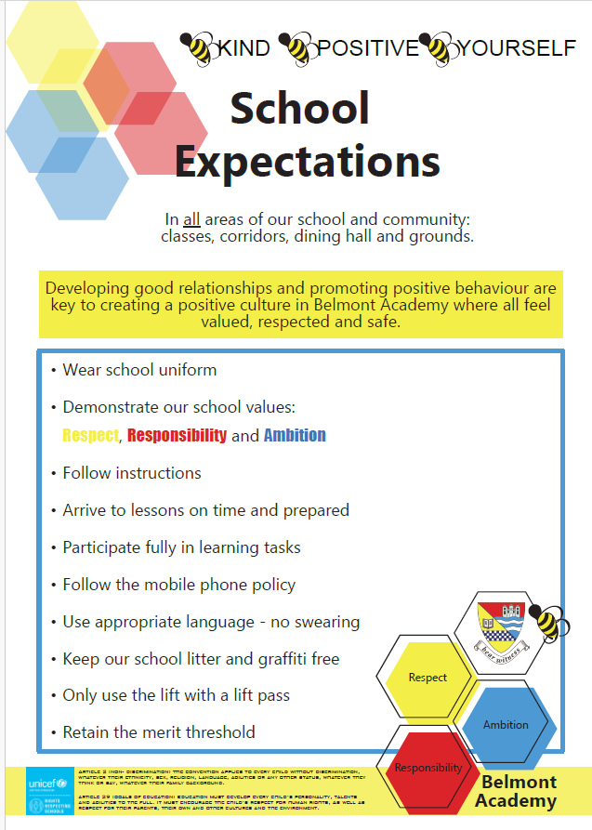

​

​

​





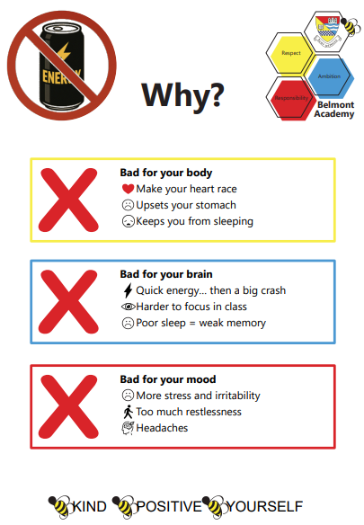



**Toilet Policy During Class Time**



*Please adhere to the following when pupils request out to the toilet*

*during your class.*

**General**

* There should only be one key in use per corridor to ensure no-one enters the toilet when already in use.
* There will be a dedicated key for each corridor.
* Identify someone in each corridor to take responsibility of the toilet door key. This can be a PT, or shared amongst staff as deemed appropriate *e.g. staff taking responsibility for a particular day.*
* Staff should organise a back-up system should the designated keyholder not be in school or be absent.

**Operational**

* The key should be signed out and back in by the pupil.
* The log should contain pupil name, name of the teacher whose class they have come out from and the time.
* Recurring pupils should be reported to PTGs through a FYI referral.
* No pupil should hand the key to another pupil.
* Pupils take responsibility for reporting any issues e.g. vandalism, not working, litter etc.
* Those with toilet passes take priority. *Staff need an updated list.*
* More than one pupil found in toilet by the keyholder will issue a lunchtime detention for each per

****School Floor Plan**

