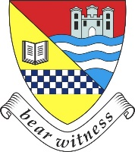
Belmont Academy:
Learning Choices S3 S4

Name: |  | Class:

S4 Core Curriculum
English | Mathematics/Apps | Personal & Social Education | Physical & Health Education | Religious & Moral Education

Administration & IT * |  | Design & Manufacture * |  | Music *
Art & Design * |  | Drama * |  | Physical Education *
Biology * |  | Engineering Science * |  | Aesthetic Physical Education (Dance etc.) *
Business Management * |  | French * |  | Physics *
Business & IT (Level 5/Nat 4) |  | Graphic Communication * |  | Practical Cookery
Chemistry (Nat 4) |  | Geography * |  | Practical Woodworking
Chemistry (Nat 5) * |  | History * |  | RMPS *
Computer Games Development (Level 5/6) |  | Languages for Life & Work (Level 4) |  | Social Subjects (Level 4)
Computing Science * |  | Legal Studies (Level 6) |  | Spanish *
Criminology (Level 5) |  | Media Studies * |  | Sports Coaching (Level 5)
Criminology (Level 6) |  | Modern Studies * |  | Travel & Tourism (Level 5)

* These subjects can go directly from a National 5 to Higher in one year

